**ICS 121 PROJECT**

**MANUAL OF JAVA-SQL PROGRAM**

**Group 2**

**Bernardo, Jesse**

**Cunanan, Patrick**

**Dalanon, Kim**

**Madamba, Chester**

**Main Program Overview:**

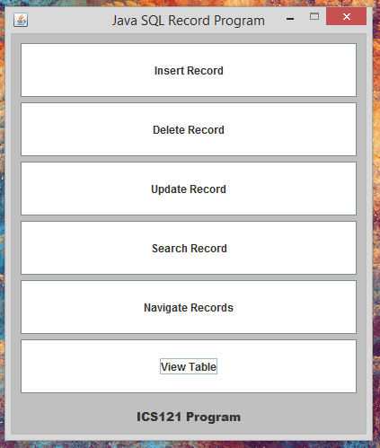

This program is a combination of the Java programming language and SQL language and database. The program consists of 6 buttons/functions that can insert, edit, delete and view records from a database.

**Buttons Overview:**



The 1st button is called the “Insert Record” button. This button’s function is to insert a record on the created table.



The 2nd button is called the “Delete Record” button. This button’s function is to delete a record from the created table.



The 3rd button is called the “Update Record” button. This button’s function is to update the data of a specific record from the created table.

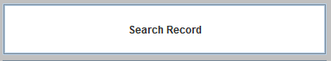

The 4th button is called the “Search Record” button. This button’s function is to search a specific record from the created table.



The 5th button is called the “Navigate Records” button. This button’s function is to navigate between the records on the created table.



The 6th button is called the “View Table” button. This button’s function is to display the created table.

**Pre-requisite of using and running the program:**

* JDK
* MySQL Database server
* Table on database consisting of the columns Stud_ID, Last_Name, First_Name, Age, Gender

**Steps in starting the program:**

1. Start the database server (This is starting the server from the MySQL workbench).

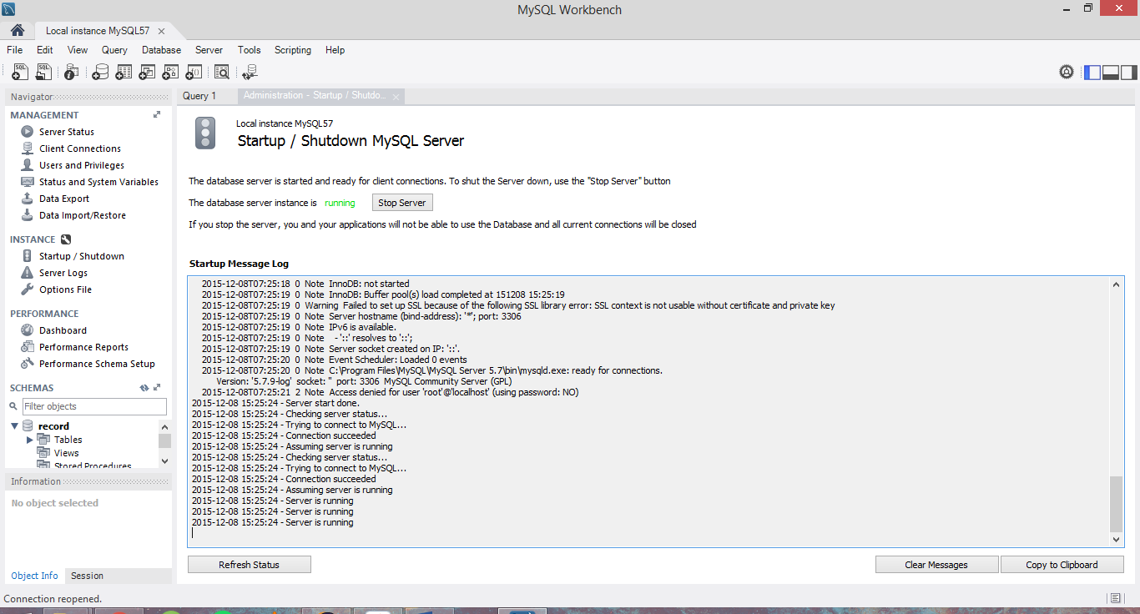

1. Starting the server can now enable the program to connect to the database server. To check if your database is working and the records are in your table, try running the command “select * from <table_name>”

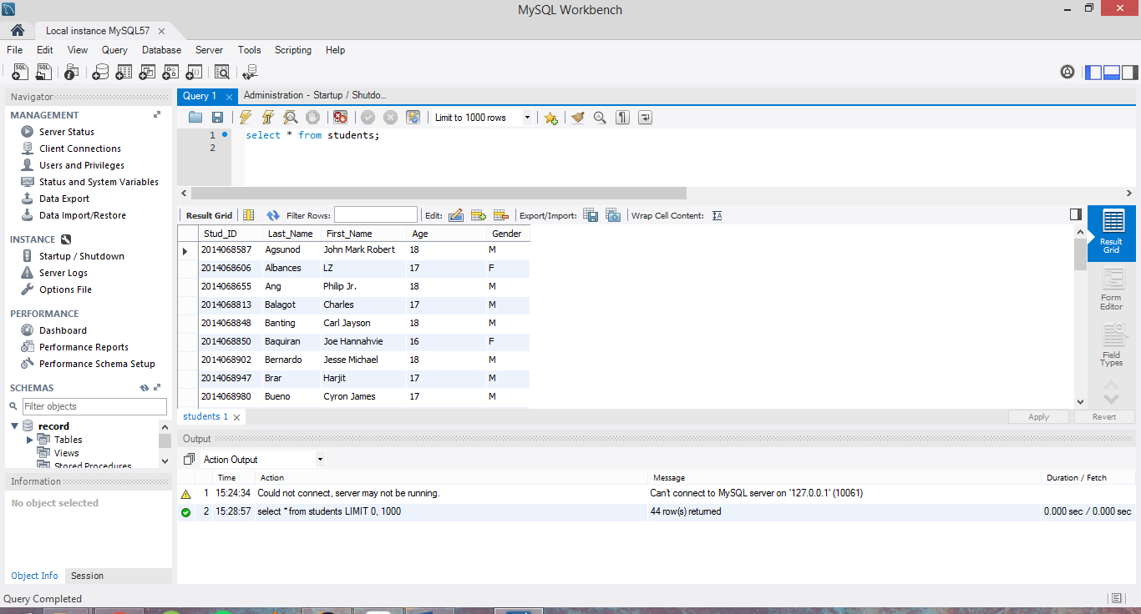

1. After that, the Java-SQL program can be used now.

**Authentication process before using program:**

1. Before using the program, a username and password will be needed.

Account to access all functions:

USERNAME: ADMIN

PASSWORD: 1234

Account to only view and search records:

USERNAME: user

PASSWORD: 1234

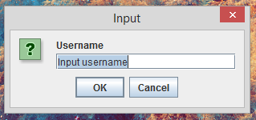

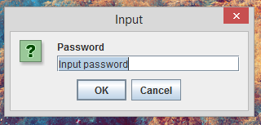

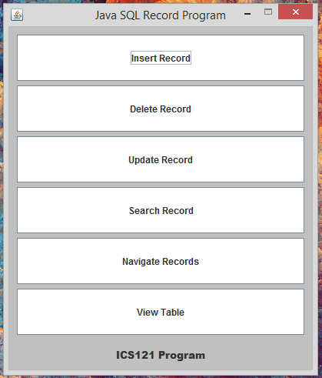

Screen with admin account

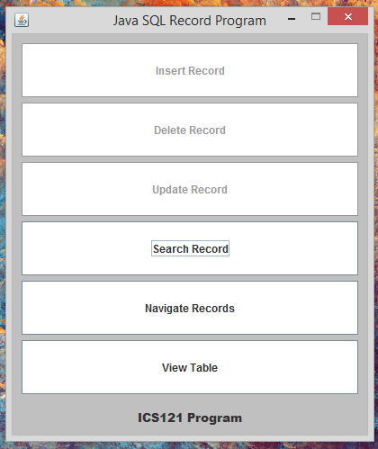

Screen with user account

**Inserting a data:**

1. You should be on the admin account to do this. Click the “Insert Record” button to open the dialog box.

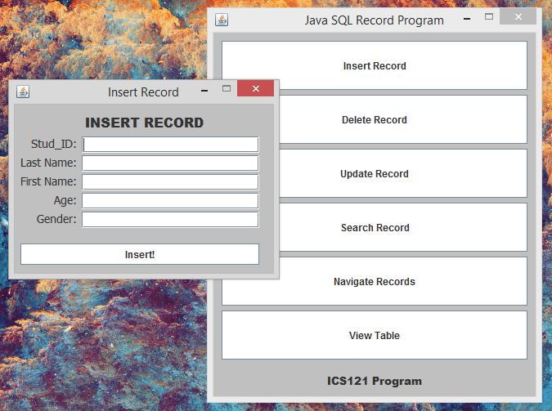

1. Enter the information to be inserted on the table.

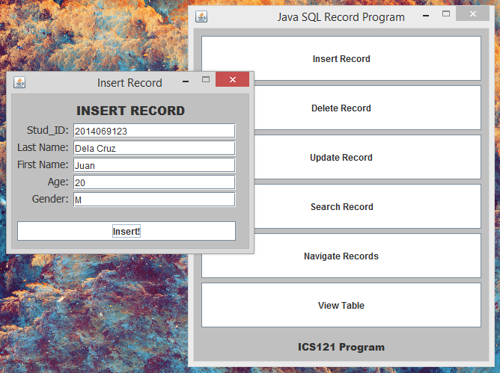

1. Click the “Insert!” button to enter the data on the table.

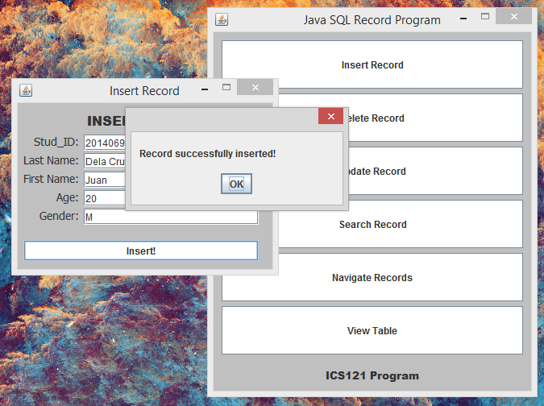

**Deleting a data:**

1. You should be on the admin account to do this. Click the “Delete Record” button.

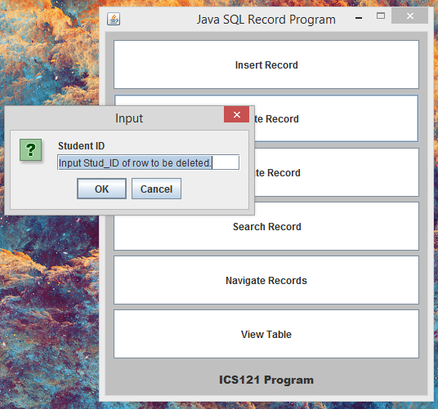

1. Since the primary key of the table is the Stud_ID, enter the Stud_ID value of the row you want to remove. Then click on OK.

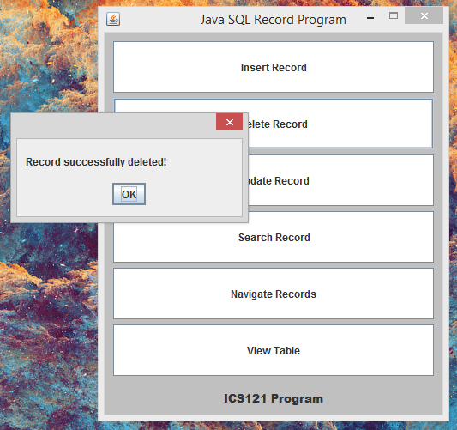

**Updating a data:**

1. You must be on the admin account to do this. Click the “Update Record” button to open the dialog box.

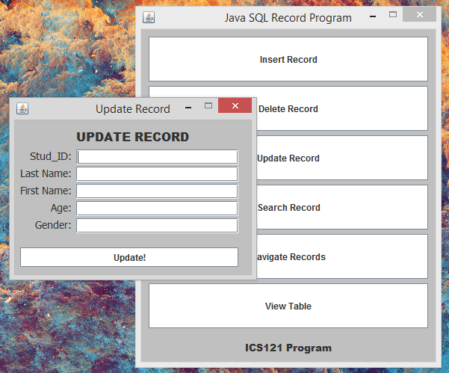

1. Input the Stud_ID of the row to be. Retype the data you don’t want to change and change the values of the data you want to change.

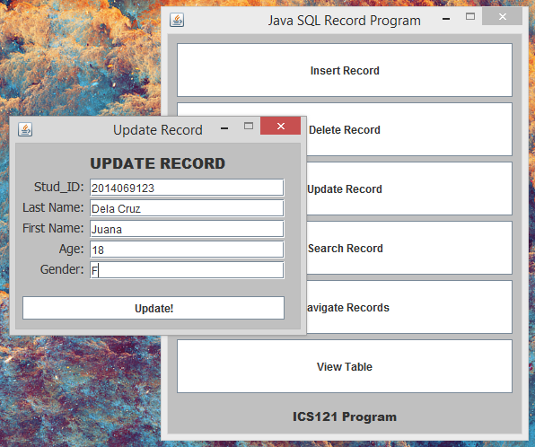

1. Click the “Update!” button to update the data on the table.

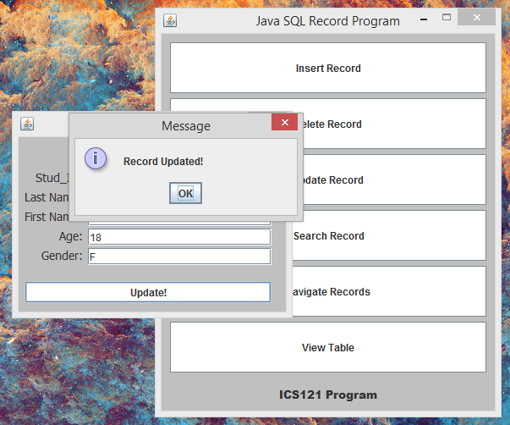

**Searching a data:**

1. Click the “Search Record” button to open the dialog box.

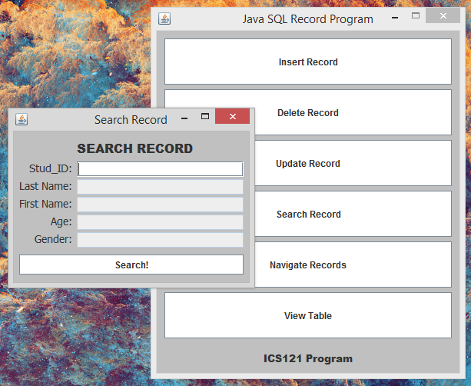

1. Input the Stud_ID of the specific record you want to see then click the “Search!” button to display the record.

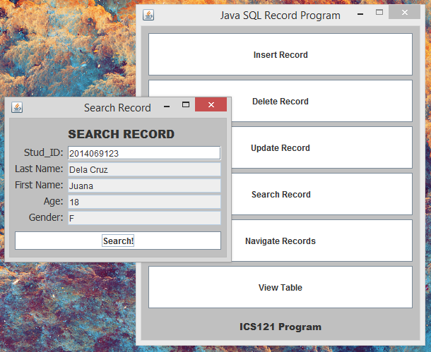

**Navigating between records:**

1. Click the “Navigate Records” button to open the dialog box.

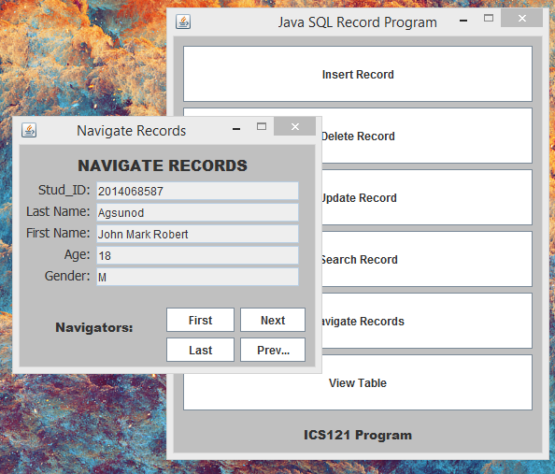

1. Use the buttons to navigate between records. The “First” button displays the first record of the table. The “Last” button displays the last record of the table. The “Next” and “Previous” button shows the next record or the previous record.

**Viewing the table:**

1. Click the “View Table” button to display the table.

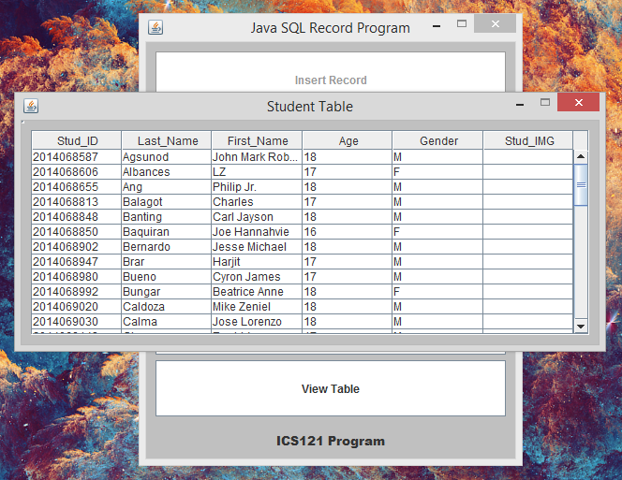

1. Use the scroll bar on the side to see the records not seen on the table.